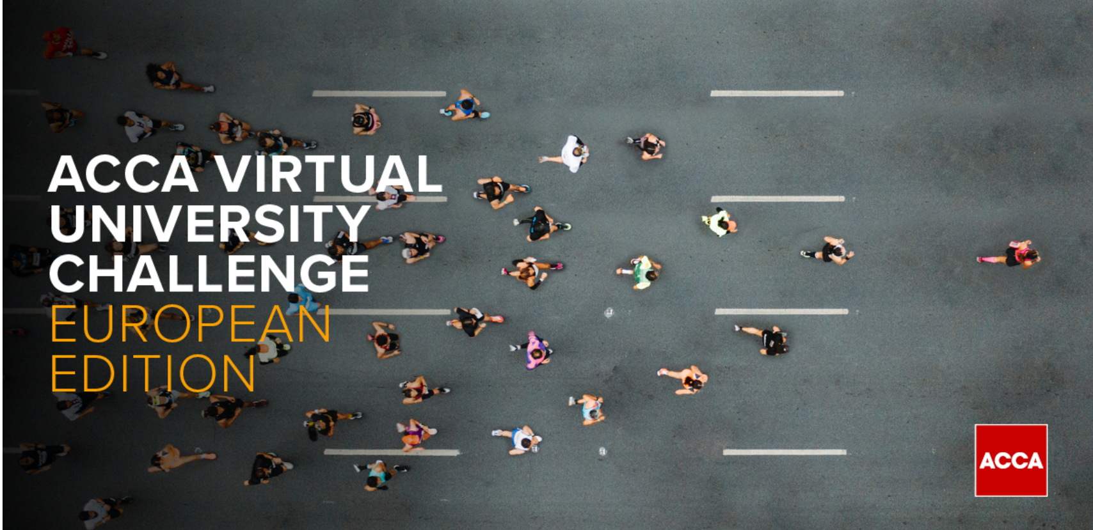

ACCA Virtual University Challenge !

Join our regional ACCA competition, win great prizes and learn how can you benefit from ACCA Qualification! How?
- You are a student in the final year of your bachelor degree or a master student in Europe and your field of study or great passion is finance and accounting. We do not accept participants who are already ACCA students or members, apart from Accelerate students!
- You will need to register here to attend our online competition https://bit.ly/VirtualUniversityChallenge, happening on Thursday, 30th of May 2024, at 6.30 PM EEST.
- Prepare yourself before the test by using our online exam resources F2 Management Accounting and F3 Financial Accounting)
- Don’t make any plans for the exam day, join us online and test your knowledge!
What can you win?
- First place an Iphone 14
- Second place a Garmin Venu S3 Smartwatch
- Third place a pair of Bose headphones
Students with good results (more than 40% correct answers) will also receive special discounts to register for ACCA. Good luck!

