**The 5th International CIMA Business Game – for students of South-East Europe!**

Dear students!

Since 2019 CIMA has been conducting competition among Universities students in few European countries - the online version of the **AICPA & CIMA Business Game**.

This year, we invite students from Romania, Greece and Bulgaria to join Ukrainian undergraduates. The competition becomes even more interesting!

The new quiz incorporated and transformed into an interactive series of questions **«KuppKarr»\*** case studies, best practices of global organizations, links to the relevant website pages and the AICPA&CIMA curriculum, and essentially became a debate on the topic of the growth of electric vehicles in the world.

Go to the link <https://sway.cloud.microsoft/kVbvl6OoYUtmCEV4?ref=email> and familiarize yourself with the terms of the game and preliminary information about the debate "pro" and "contra" electric cars in the world. This is a very relevant issue, as evidenced by numerous articles, studies, and videos that you will find at this link.

Only after preparation go to the quiz itself - [**KuppKarr (The rise of EV cars) - EU2024**](https://forms.office.com/pages/responsepage.aspx?id=YeJEqynjJ0O73RelR4ImocrR9qPhmmxCo8tg3DPm_oNUME5RQzgwVTZCTVJGQUJLUkU0MVY4QThIQS4u&route=shorturl)and offer your solutions to the questions and problems facing modern business and the world.

This will be a great opportunity for you to get to know CIMA and its qualifications, as well as take part in solving real issues and problems facing modern business.

**The game period is October 14 - November 20.**

The game consists of **24** multiple-choice questions (100 points in total). The passing level is **75** points. Time and number of attempts are unlimited.

Each participant must provide an e-mail address, first and last name (in full, in English), university, faculty/specialty.

At the end of the game, the player who received 75 or more points must take a screenshot or a photo of the screen showing his name and final score and send it to **cima.see@gmail.com** to receive a certificate.

We will be very happy if the winners post their photo with the certificate on social networks with a link to #CIMA. AICPA&CIMA will also recognize the best players and post information about them on its pages in social networks.

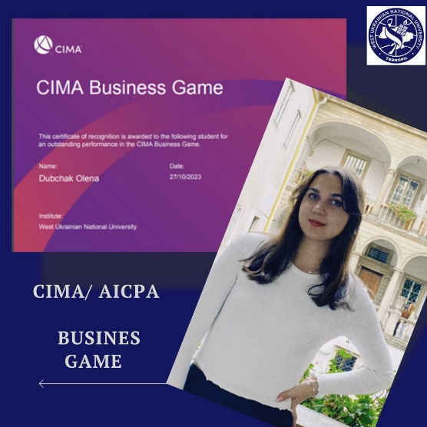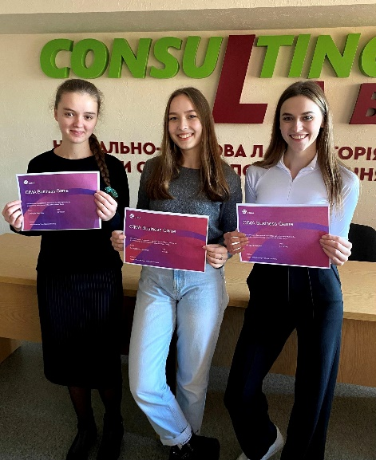

_____________________________________

* "KuppKarr" is a fictitious company, one of the world's largest car manufacturers, which announced that it plans to stop developing new models of cars with internal combustion engines ("ICE"), which are based on gasoline or diesel fuel. It will continue to produce existing models as long as there is sufficient demand worldwide, but the company plans to switch completely to electric vehicles.

Other major manufacturers are likely to follow suit. Many countries have committed to phase out ICE cars due to environmental concerns.

However, according to recent news, EV sales in Wellandia (a fictional country) remain low, and most motorists continue to buy cars that run on gasoline or diesel.

Consumer surveys show that motorists in Wellandia are reluctant to buy electric vehicles due to the limited availability of charging points in their country. Depending on the model, some electric vehicles have a range of only 170 kilometers, after which their batteries need to be charged. Many motorists are concerned about the possibility of being stranded if their cars run out of power before they find an available charging station.

Quiz questions will focus on the following areas:

• Breakthrough technologies in the industry

• Business risks

• Training and software issues

• Variants of implementation of the decisions of the top management

• Pricing strategy

• Integrated report

• Risks and opportunities

• Involvement of key employees